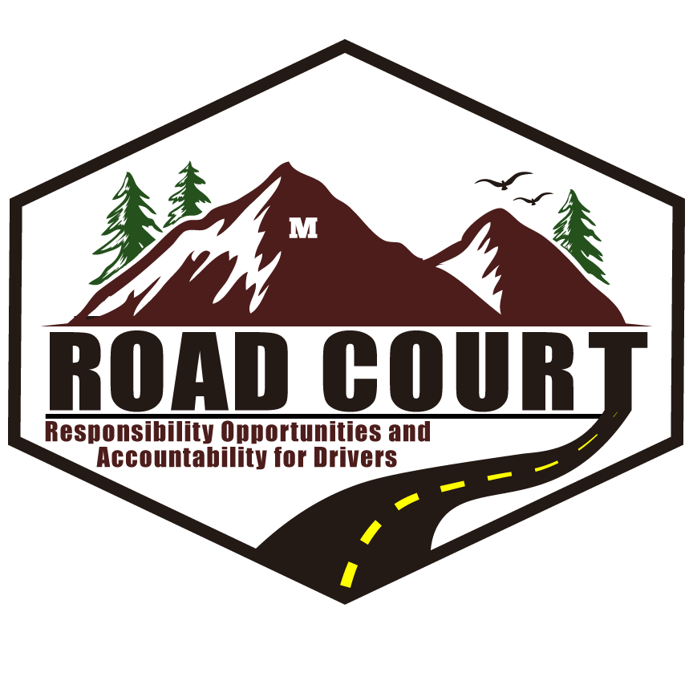
REFERRAL FOR
ROAD COURT
Responsibility, Opportunities and Accountability for Drivers

Date: __________________________

Name of Person Referring: _______________________________________________________________________

Contact Information: ______________________________________________________

Relationship to Defendant: Defense Attorney Prosecuting Attorney
Probation Officer Other: _______________________

Defendant Full Name (include any alias): _______________________________________________________________________

DOB: _______________________________ Contact Phone #: ___________________

Prosecuting Attorney: _____________________________________________________

Defense Attorney: ________________________________________________________

Missoula County Justice Court
Municipal Court
Missoula County Justice Court and Municipal Court (please list all case # / pending charges)

Court Case #: ____________________________________________________________

Pending Charge(s): ________________________________________________________

Type of Charge: New Offense
Probation Violation

For Office Use Only:

